- Open the link in browser https://www.internetsociety.org/become-a-member/

- Scroll down and click on “Become a Member”
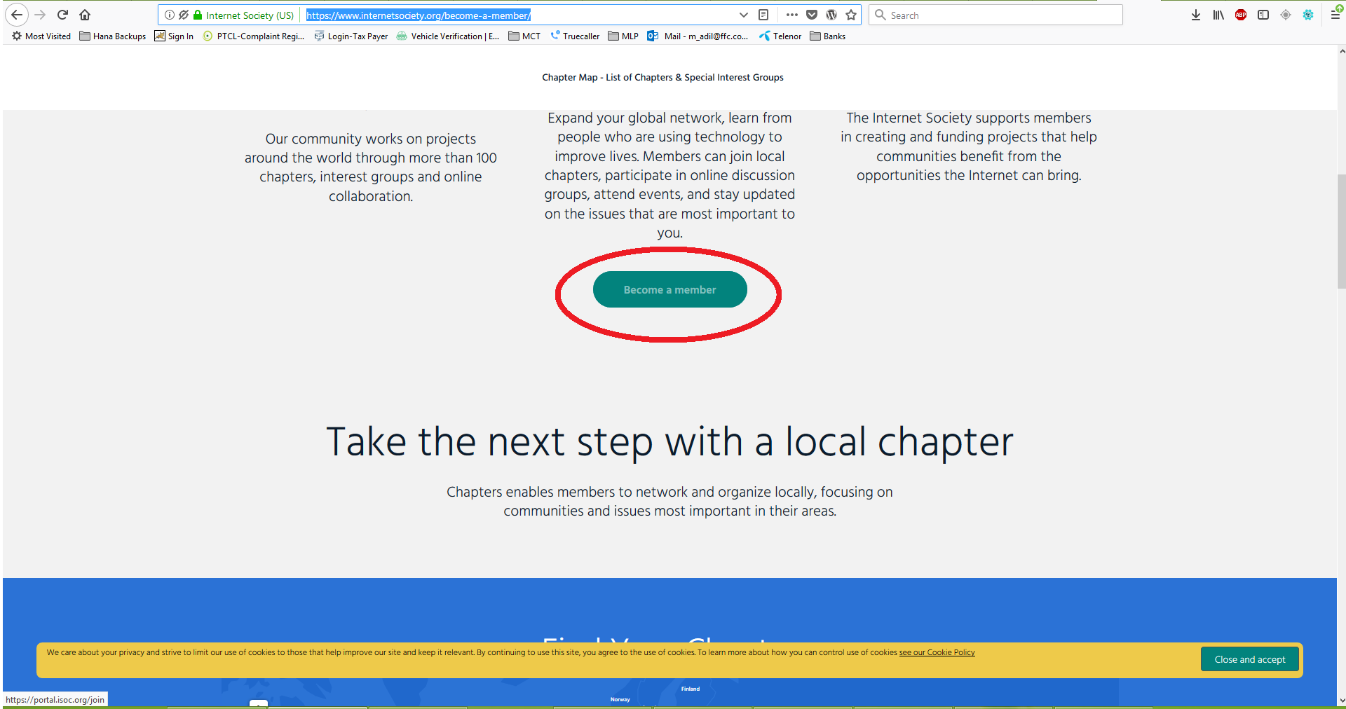

- Fill out the simple form with your details and click on “Join Now”.
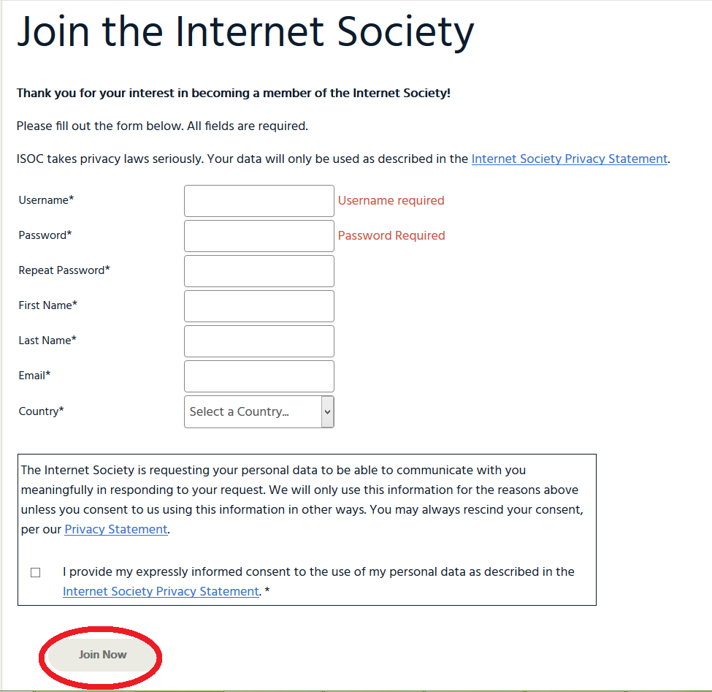

- After creating the account login the portal.
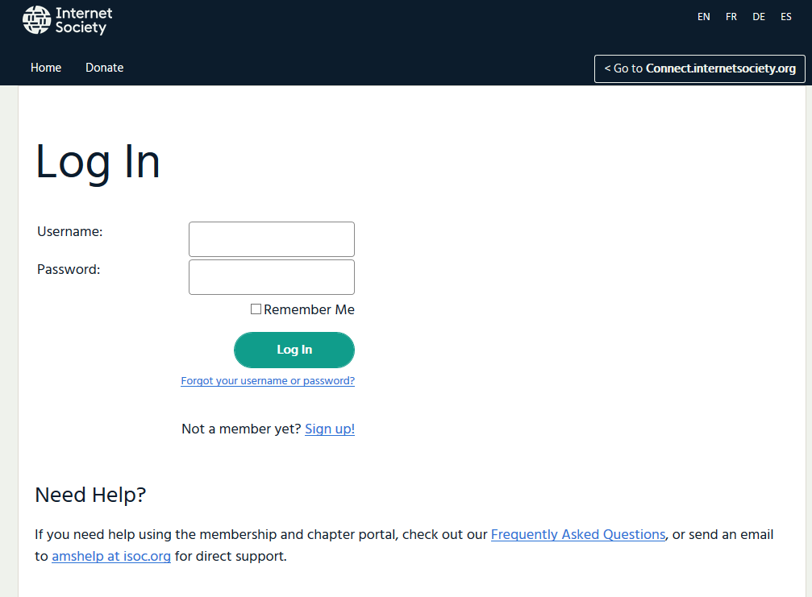

- Once logged in, from the dashboard click on “My Chapters”
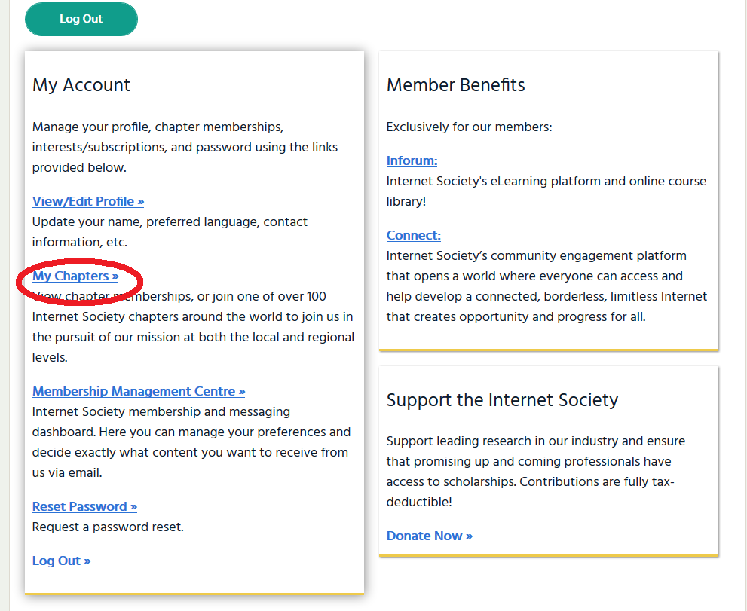

- From the next screen, click on “Join a chapter”.
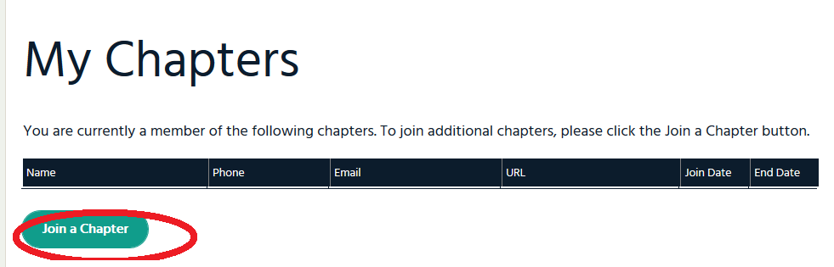

- From the next screen scroll down and select “Pakistan Islamabad Chapter”
- Then at the end of the screen click as per below picture.

- Your request will land with the chapter executives for approval, once confirmed you will be part of our chapter.

